Appraisal

1.1 Comparison of project performance against the objectives

From first principle, this piece of software was designed to meet the following objectives (Analysis, 3.1) –
Standard Functions
1.
- Upon completion, this software should allow the end user to keep track of web browsing on the target computer.
- Browsing history can be checked and filtered by date, hit counter, or type.
Intelligence functions
- Data logged to the database will be filterable via a special function that will intelligently recognize the nature of each website, and log them into the database.

From this, the following system specification was established (Analysis, 3.2) –

- Core program (running on Anna and John’s machine)
  - Security
    - Invisibility (can’t be closed or exited) - done
      - Program will run as System Tray Icon
    - No setting will be changeable from Core. - done
    - Will launch on every system boot up – not done
      - Can be set inside the system registry.
  - Design
    - The program will run as a background process with no user interface (faceless program, tray icon) - done
  - Implementation
    - The core will be placed on the system without any installation process - done
    - The machine on which it is placed will have an extra modification so it runs the core on each system boot up (as mentioned above) - not done
  - Function and process
    - Input data
      - Inbound traffic (HTTP (strings)) - done
      - Website IP address (numeric) - done
      - Website URL (alphanumeric) - done
      - Timestamp taken when inbound traffic is received (datetime) - done
      - Connection to a datacentre to which it will transmit output data. - done
    - Output data
      - Website IP (numeric and dots) – not done
      - Website URL (alphanumeric) - done
      - Website description (string) - not done
      - META tags (single words) - done
      - Timestamp (datetime) - done
- HQ program
  - Security
    - Prompt parent for password- done
    - Restrain malicious data from being processed- SQL query injection for example, or bad data. - done
    - Use regular expressions match password to format- done
    - Check inbound URL’s to match them to the x.y format via regular expressions. - done
  - Design
    - HQ will be a webpage (PHP, CSS, HTML) - done
  - Implementation
    - HQ will be hosted on a public or private webspace, with PHP compatibility. - done
  - Data manipulation
    - All data will be fetched from the database (shared between the Core and HQ) - done
    - Data will appear on the web page and will be sortable depending on filters applied (time, hit count, genres...) - done
    - Data stored in the datacentre can be deleted. To do so, they can select what data to delete. - done
  - Intelligence features
    - Websites will be categorized into recognized groups (game sites, maths sites, misc, etc…) all visible via a filter applicable on the website. - done
Based on the statistics measured before implementation, Eyespy will calculate whether the statistic for that day are higher than the mean of the statistics for that day measure before implementation, and notify the user if the mean is met or not.

The text presented below will refer to the above listings in the following way:
- o2.d → Objectives section 2.d
- s2.d → Specification section 2.d

Comparing the objectives to the specification, we can establish from the first principles the required specification – a platform with stored data (o1.a) will required a database to store the data (s2.d), in this case, a MySQL database.
Following this, a platform will be needed to
- Display data
- Fetch data
The most adequate to fill these needs would be
- a) an HTML designed website
- b) PHP to query the database and display the results on the site.
These needs (o1.b) have been met by (s2.b.i), the end-user can now consult the data via the Eyespy HQ webpage (Design, 2.2.1). The user will be prompted for a password which must be in the correct format, in the case that it presents a malicious objective; it will be filtered by the regex.

The next issue was to make the data on the platform display what the user requested, which is – as stated – the top 10 visited websites, and the last 10 visited websites. The data would need to be viewable statistically and factually. These criteria were stated by my user during the interview and were integrated as seen in Design 2.2.2 – this integration translates from the Objectives 1.b to the Specification 2.d.11.

The available view of data currently presented by Eyespy HQ matches the exact demands of the user, as seen in the Interview and Analysis. The (o2.d.iii) specification has been met via a design feature, implemented within one of the tabbed content panels.
The view of data, following a brief conference with my user, has been cut down to a non-interactive table of data. With various models of analysis presenting either a ‘top 10’ or a ‘last 10’ my user can happily get accurate understandings of how the internet is being used, as the top 10 will allow them to get a dynamic view of che change in categories.
With the implementation of the intelligence feature mentioned in e1, tracking the different categories of websites visited is easier than the previous system, where checking the browsing history meant checking each URL.

Upon final conference with my user, we discussed how relevant the data being collected by Eyespy is, and how useful it is to them it is to analyse. We discussed the fact that Eyespy currently collects IP addresses for websites, and a meta-description, my user decided that they no longer thought these informations were needed, as the IP address is not content-related and the description can be summarised by the keywords.

Also, following testing on the host-machine and review of data, my user asked if it would be possible to have more keywords describing the categories. As a result of this input, I've re configured the Core so that the first three keywords are fetched and inserted.

The final Eyespy HQ product is as follows –
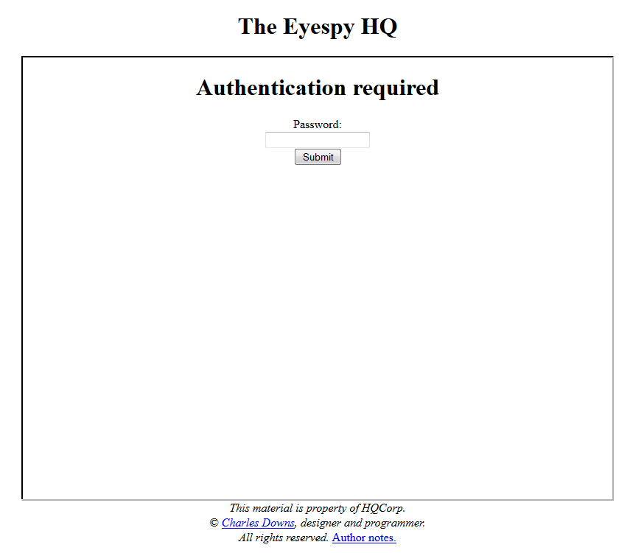
User login:

Main page:
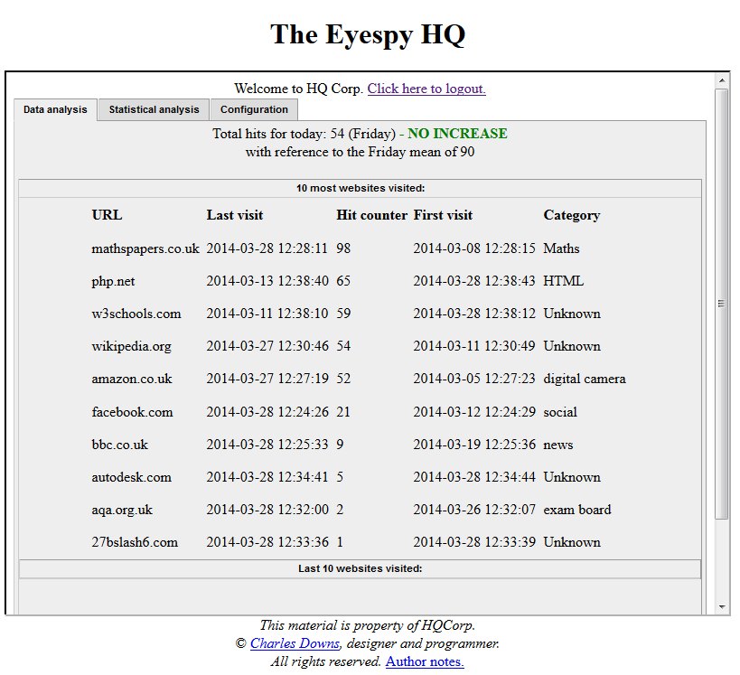

Concerning Eyespy Core, my user demanded an application that would run silently with no use interface (s1.a), this criteria has been met by developing an application which would run as a discrete system tray icon, as follows-
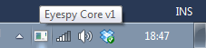
No settings can be modified from the Core program, nor can it be quit by any means other than system reboot.
The specification mentioning that the Core should start on system boot up (s1.a.iii) has been decided against by the user. They would like to have control over when the program is logging data and when it is not, so they can use the computer without skewing the websites Eyespy Core is keeping track of. They also do not have the technical know-how to edit Registry options (s1.a.iii.1).

Right clicking on the Eyespy tray icon displays the context menu:
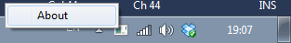
The only item within the context menu is used to print a trace of the current state of the input variables, as seen blow:
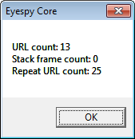
The URL count is the number of URL’s that have been successfully been processed, the “Stack frame count” is the amount of times that the stack has reached its maximum size and reset itself. This occurs when the number passed as parameter for the stack size is reached, avoiding buffer overflows.

1.2 User Feedback

After completion of the project, I installed it on my user’s machine, following a few days usage, they reported back to me – the transcript of our phone call is as follows-

From: The Smith Family
First of all, we would like to thank you for the time you invested in designing ‘Eyespy’ for us. Not only have you supplied us with an excellent way of keeping track of how Anna and John use the Internet, but you have also familiarized us with various aspects of computing that we previously were unaware of. The platform you have provided us with - ‘Eyespy HQ’ - is simple and effective, providing us with the exact data we wished to track. We would also like to thank you for your insight in the design of this program, your mathematical perspective and suggestions, such as tracking statistics for each day of the week, have allowed us to analyze the data in a whole new light, allowing us to see how the overall usage of the internet has evolved over long periods of time. We are extremely pleased with the design of the HQ, the two tabs, entitled “Statistical Analysis” and “Data analysis” allow us to switch between two different analysis types depending on how we wish to filter the data - we could not have wished for a more convenient design and navigability.
Overall, Charles, you have proved to be an excellent designer, but also you were able to analyze the problem from our perspective, giving us guidance and counsel on the various aspects we wished to develop. We are very glad we listened to your advice.

As you requested. we have answered your questionnaire below -
How easy is Eyespy to use? Have you encountered difficulties using the HQ platform, or launching the Core program?
Absolutely not. It takes a mere click to launch the Eyespy Core, it then proceeds to catch data without any issue. Using the Eyespy HQ is also very easy, with the only input being the password, it is very easy to navigate and find exactly what we want.
How does the final product compare to the spec we originally established?
The final product differs slightly from the original spec, which is not a bad thing. The original spec we wrote was ‘blind’, the program was not yet written and we couldn’t think about it as much as we would when nearing completion. You advised us of changes that you thought would improve the program, which indeed changed the program for the better. In retrospect, we believe the original spec was very messy, and would not have given a better program if you would have followed the original spec. We are grateful for your input during the development of this program.
If you could request an improvement, what would it be?
We are not software developers, and as far as we can see, the final product provides us with exactly what we wanted, and is better designed than any commercial software we could have purchased. You tailored this program to our exact needs.
During the development of Eyespy, I changed the specification multiple times upon conference with you, this was as I was developing the software in realtime. What is your feedback on this?
As we mentioned above, we are very pleased that you foresaw better development routes - as you were the one designing, you noticed flaws in our original specification, and were able to correct them, an example would be when we requested you to have various forms of input, such as day, month and category. You saw a better way of implementing this, via collapsible panels, which are very elegant and much nicer to use.

Having read the letter form The Smiths, I am pleased that they noticed my input during the development of the software, and I am very content that they are happy with my input, I believe it was hard for them to establish a thorough specification without any knowledge of how it would look. Conferring with the Smiths was key during the development of the application, as the final design differs a lot from the original design, and so do many of the functionalities used in the analysis mechanism. They are also not very computer-able, one might say, which posed another problem during the technical stages of the development, which meant I had to report back to them with a lot of visual material. It was also difficult to establish the usage of various programming languages from first principle, as I had to decide that the platform would be a website, initially. As they could well have ended up with a program-based data consultation platform.
Throughout the development days of the software package, the view-of-design had changed from user-specified specifically-user-tailored, the great advantage of this is that now, Eyespy can be used by any environment, corporate or educational, with ease of access and usage, the multi-platform principle underlying the package (web application for Eyespy HQ and C# tray application for Eyespy Core) makes it easy to navigate through the data output. Another point not mentioned during earlier stages of development: the remote location of Eyespy HQ makes data accessible around the clock and around the world, which leads me to another greater overall factor of usage: any organization wishing to make use of the Eyespy package may check the in-stream of data anytime, anywhere.

On the improvement side, there is a lot to say, as the underlying function of Eyespy is a statistical model, many more functionalities could be implemented, as the usage of statistics is vast. New methods of analysis could have been implemented, such as using Variance as a model of analysis, or even the Chi-Squared test. The field of statistics is vast, and Eyespy relies on various models of basic statistics, such as Medians and Means. A major extension to the project would be the incorporation of Probabilities, for each day of the week, a probability of which category would have the most visits could be calculated, and so on.
On the whole, I do strongly believe the Eyespy Core module should be ported to C++ (as foreseen and mentioned in section 9 and 10 of the Analysis document).
This would allow way for performance improvement, as C++ is a faster programming language, not requiring any structural framework like C#, which leads me on to another point, porting the module to C++ means the elimination of .NET Framework.
The .NET Framework requirement of C# currently means any host-system wishing to run Eyespy Core MUST have .NET Framework as an extra system-requirement, which means the user desiring to use Eyespy must consecrate more hard-disk space than they need, and allow for them to manually install .NET Framework.
I believe there is room for a LOT of improvement within Eyespy.

On a personal sidenote, I’m very pleased with my idea of conceiving a standalone testing program – HTTPWriter – to be able to ensure that the Core module is robust enough before building on the HQ, who’s primary functioning is reliant on the communication between itself and Core. This program allowed me to test all kinds of data and ensure that the communication line was possible between two separate programming languages, C# and PHP. The raw-text-type communications worked fine, the only issue, that was solved by HTTPWriter, was that at runtime, C# would terminate each string with two escape characters: “\n\t” which was very quickly picked up by the HTTPWriter testing module that I embedded within the Core, as when a link was rejected by the HQ, the HTTPWriter module would say output the rejected URL, which contained the two escape characters. Solving this was a matter of truncating the string right before sending it to the HQ.

On a more general note, the current Statistical Model used by Eyespy is a static model, meaning that the statistical data (means, averages, medians) entered by the user when they set up the package will remain the same until changed. A great improvement that could be made to Eyespy would be the adoption of a dynamic statistics model. For example, every week Eyespy would read back on the volumes of data handled for that particular week and update the means/medians/averages to fit the new data. This would allow the user to observe whether the overall usage of the internet is increasing or decreasing over time. Moreover, WHEN it increased and WHEN it decreases. For example, one might imagine that during the summer the usage would be at a trough, whereas during the winter, it might be at a crest.

